**Lecture 5. Switch Statement**

Switch statement is used to easily select one option from a number of options when making a decision.

**How it works?**

* A **switch value** is compared to a list of values called **cases**. The switch value might be a variable, an expression, or a direct value.
* Whenever is found that the switched value is equal to a case value, the block of code associated with that case is executed.
* The execution continues with the statements of the next case (or cases) until the **break** statement is encountered.
* The **break** statement is used to prevent the execution of the case or cases that follow. The **break**

statement is optional.

* If no case value is found to be equal to the switched value, a special case called **default** is executed. The default case is optional.

Syntax

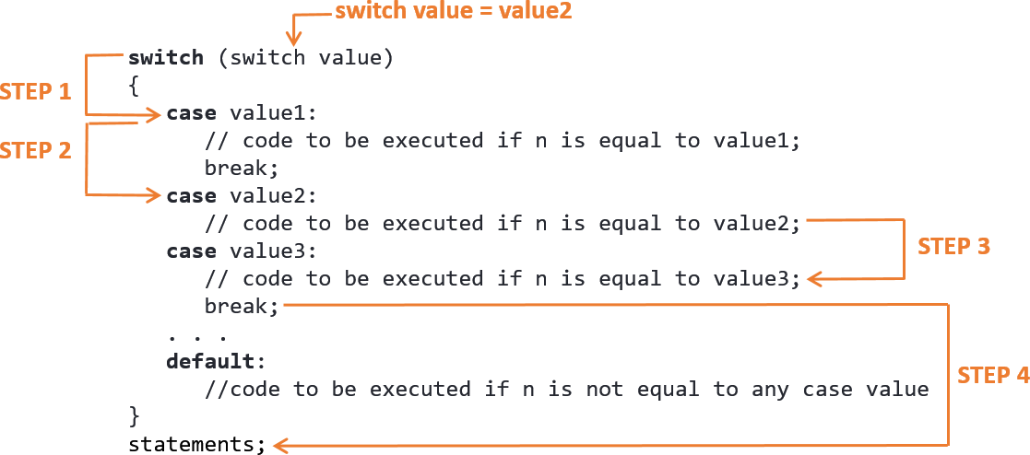

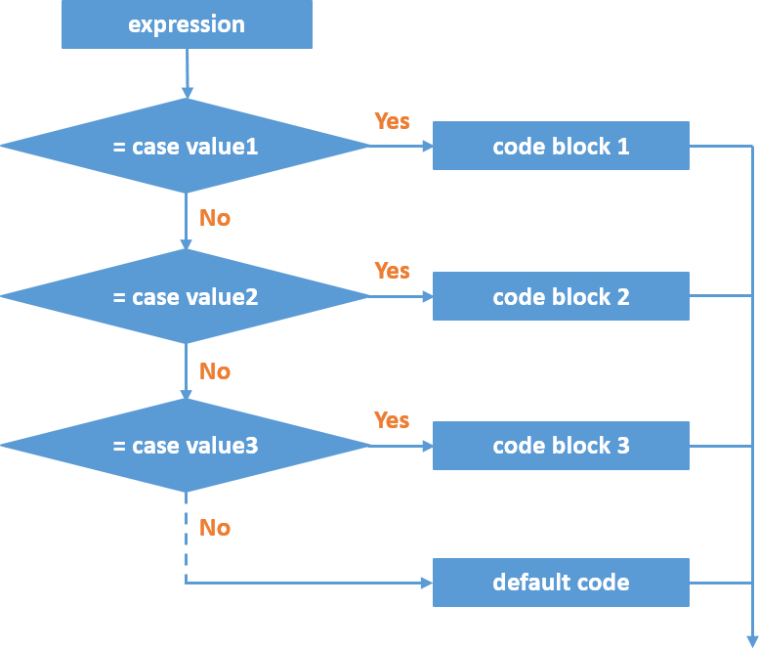

switch Statement Flowchart

Rules to follow when using **switch** statement:

* **switch** and **case** are keywords; must be written in lower case letters.
* Relational operators are not allowed in switch statement.
* The data type of case value and the switch value must be the same: **integer** or **character**.
* A switch statement can have any number of cases.
* Each case is followed by the case value and colon (‘:’).
* Two or more cases can share one break statement.
* The case values can be in any order.
* The **default** can be placed anywhere in the switch.
* No break is needed in the **default** case.

Example:

int i= 2; switch (i)

{

case 1:

printf("too low"); break;

case 2:

case 3:

printf("good number"); break;

default:

printf("too high");

}

# References

* Tan, H.H., and T.B. D’Orazio. *C Programming for Engineering & Computer Science*. USA: WCB McGRaw-Hill. 1999. Print.
* Tutorialspoint.com. "Switch statement in C." *Www.tutorialspoint.com*. N.p., n.d. Web. 14 Feb. 2017.

<<https://www.tutorialspoint.com/cprogramming/switch_statement_in_c.htm>>.

* Rajinikanth. "C Programming Language." *C switch statement | c control statements | conditional control statements in c | C by Rajinikanth | C Programming Language*. N.p., n.d. Web. 14 Feb. 2017.

<<http://www.btechsmartclass.com/CP/c-switch-statement.htm>>.

* "C switch...case Statement." *C switch...case Statement*. N.p., n.d. Web. 14 Feb. 2017.

<<https://www.programiz.com/c-programming/c-switch-case-statement>>.